**R Installation 4.0.4**

**Pre-requisite for R Studio is R Installation 4.0.4**

1)Go to below link and install R for Windows

**https://cran.r-project.org/bin/windows/base/**

**(For Mac Os https://cran.r-project.org/bin/macosx/)**

2)Run the exe by selecting Run option.

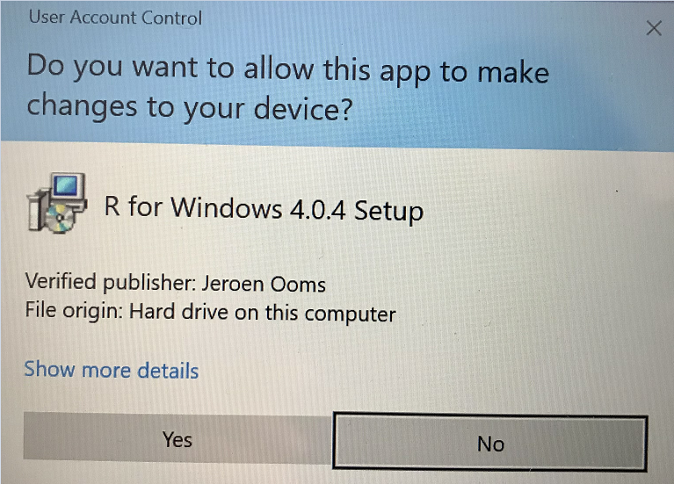

Click on Yes

3)Select your language preference and click OK.

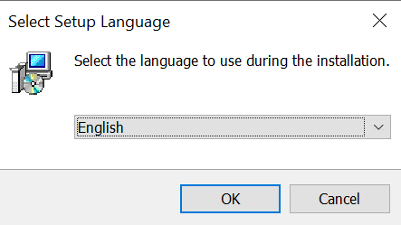

4)Click Next.

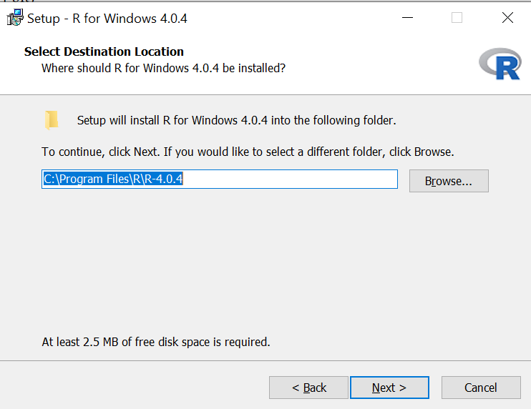

5)Click Next.

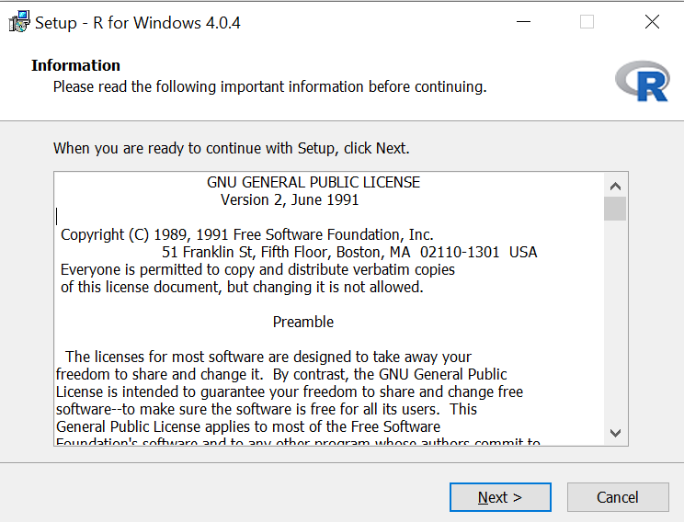

6)Click Next

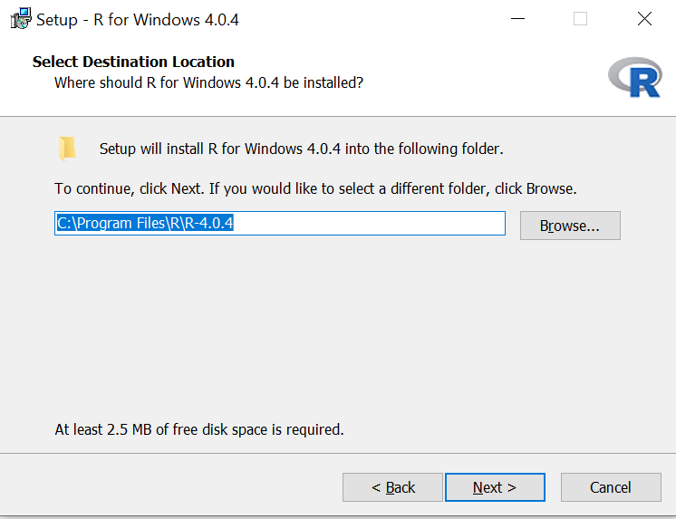

7)Click Next

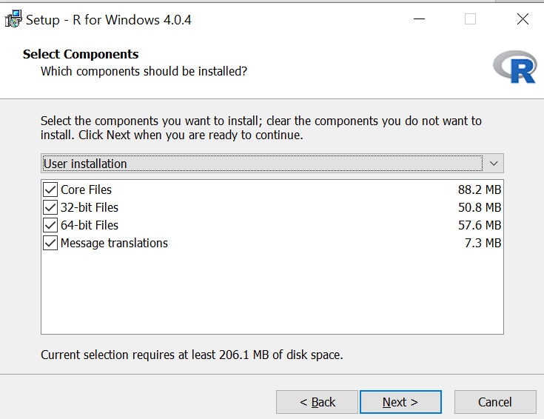

8)Click Next

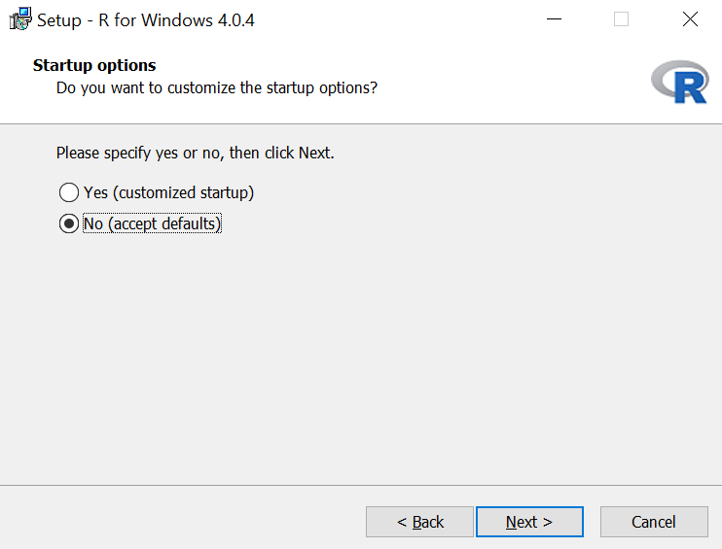

9)Click Next

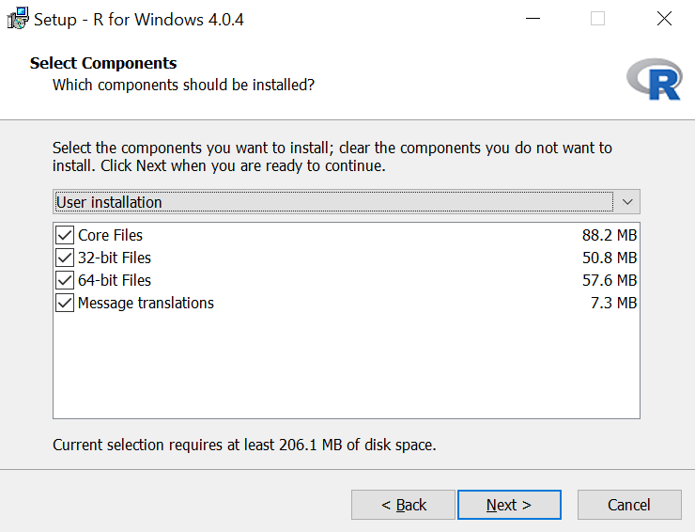

10)Click Next

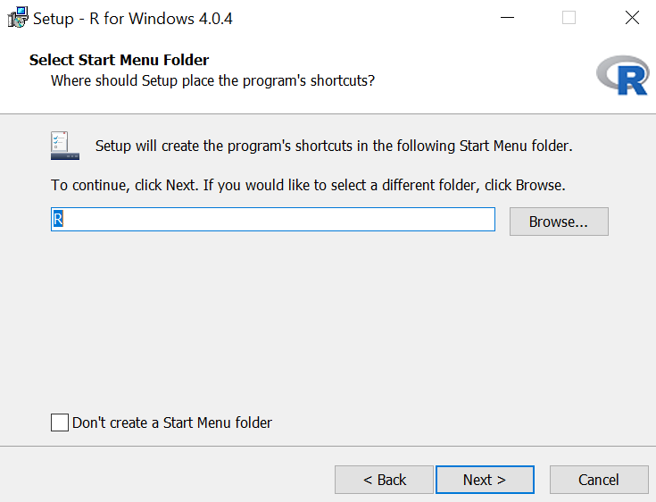

11)Click Next

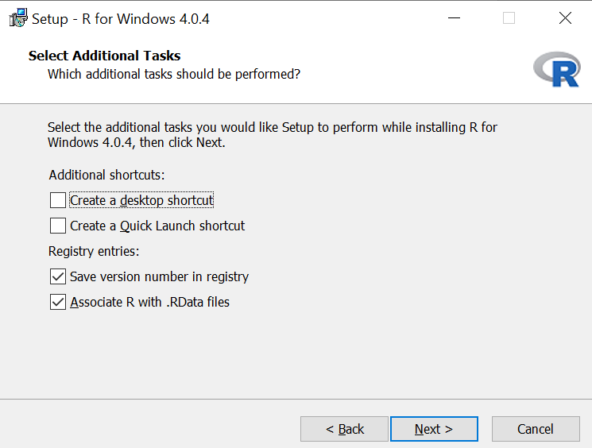

12) Wait for the installation to complete

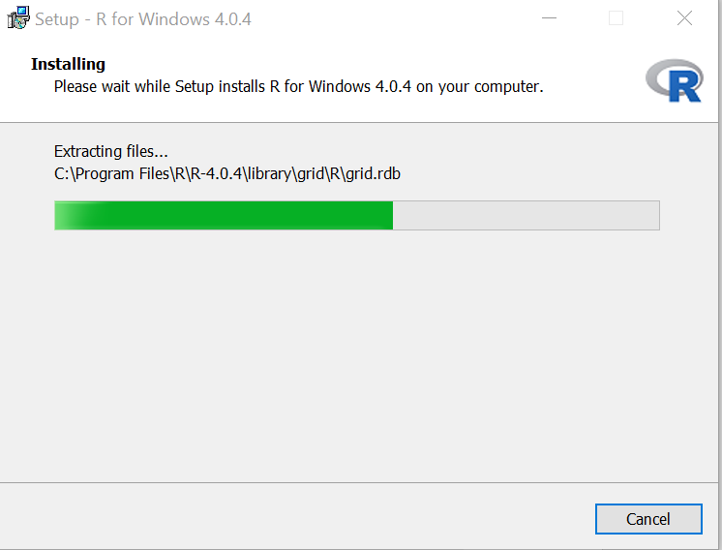

13)Click Finish. R installation is now successfully completed.

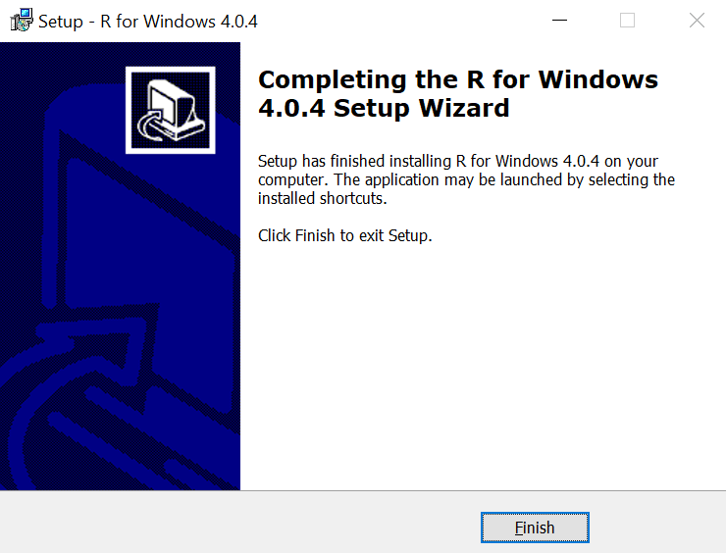

**R Studio Installation**

Install R Studio once the installation of R 4.0.4 is completed.

1)Go to the below URL

**https://www.rstudio.com/products/rstudio/download/**

2) Under the installer for Support platform select the file that is suitable for your environment (e.g. For **Windows** user select file **Rstudio-1.4.1106.exe)**

3)Once the download of the file is completed, click on the exe file.

4)Click on Run.

5)Click Next

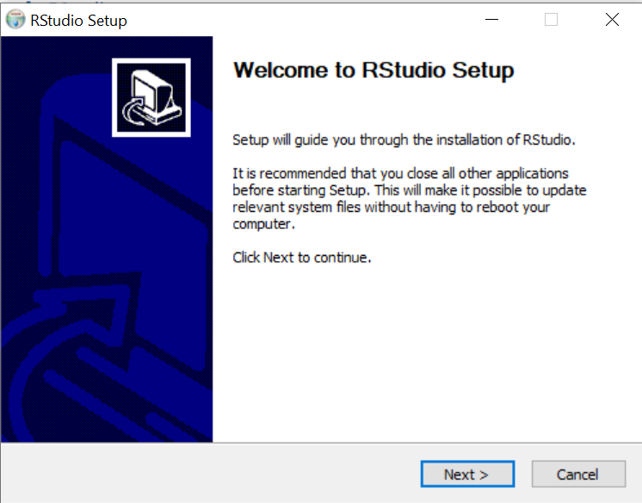

6)Click Next.

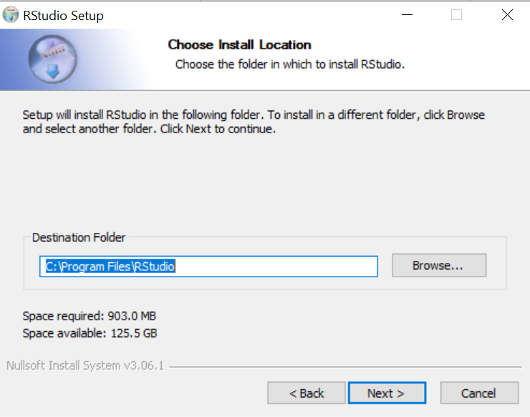

7)Click Install. check the box to create shortcuts.

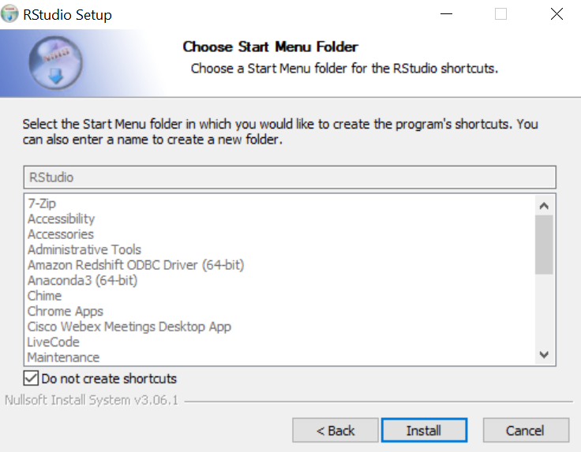

8)Wait for the installation to complete.

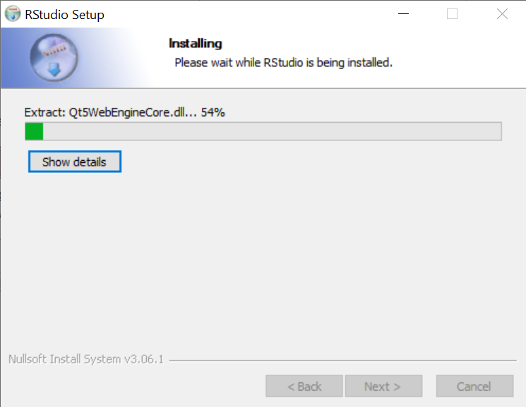

9)Click Finish. Your installation is successfully completed.

